Prompt Engineering Basics and Requirement Gathering Feb 25, 2026
This content focuses on the basics of prompt engineering and its role in requirement gathering using generative AI.
Understanding Prompt Engineering
- Prompt engineering involves crafting clear and specific instructions for generative AI to produce focused outputs.
- Vague prompts lead to vague answers, while well-structured prompts can transform scattered ideas into actionable insights.
Crafting Effective Prompts
- Clarity and specificity are crucial; straightforward language prevents misinterpretation, and detailed context enhances the quality of responses.
- A structured approach to prompts includes defining the role, task, context, and format to guide the AI effectively.
Benefits of Generative AI in Requirement Gathering
- Generative AI can quickly draft requirement documents, maintain consistency, and generate useful questions or checklists.
- Well-designed prompts can convert broad business needs into detailed, actionable requirements, aiding in system design and analysis.
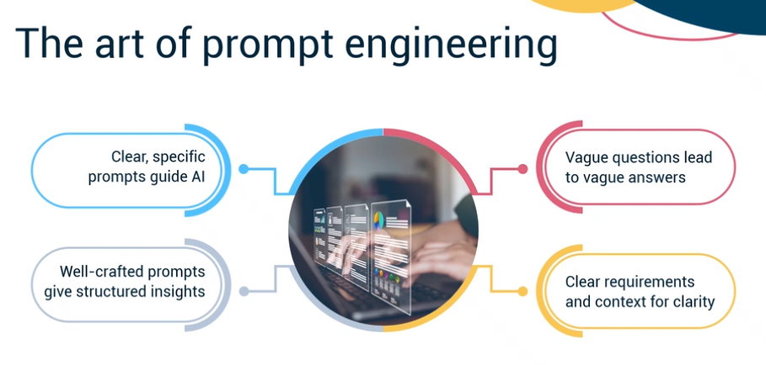
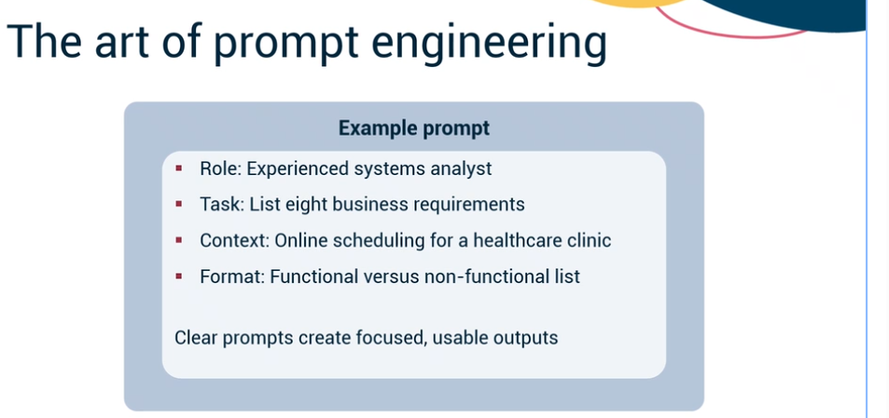
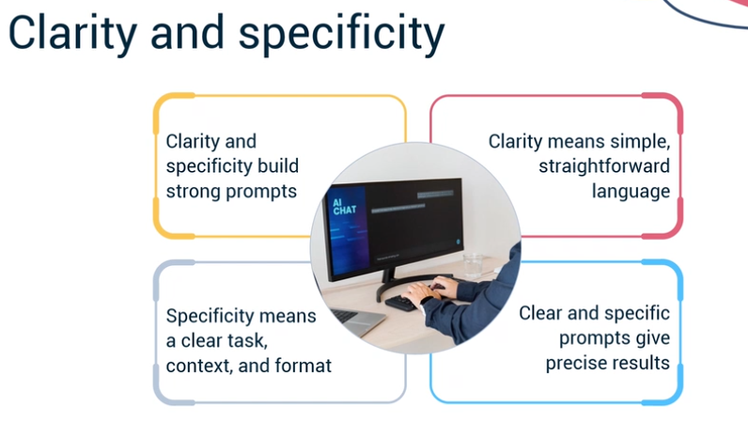
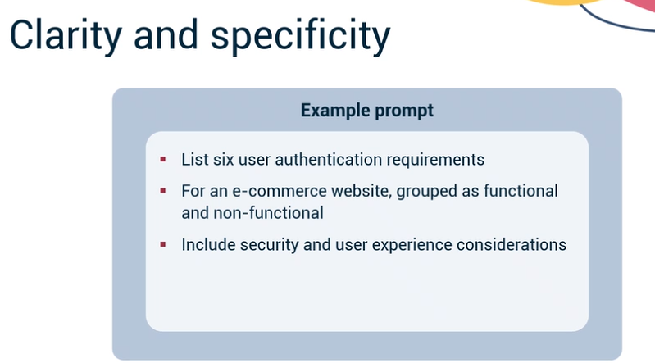
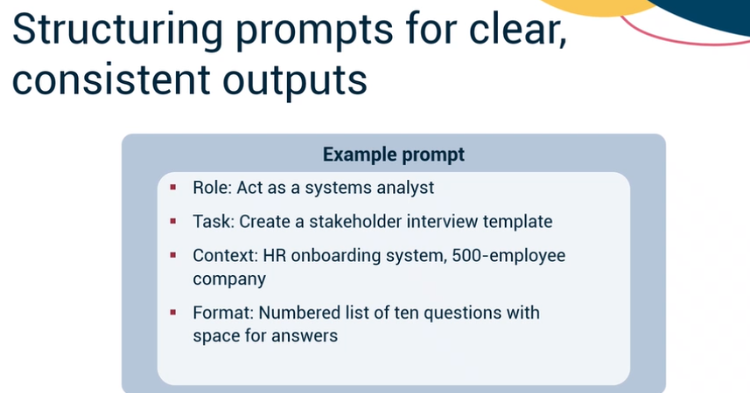

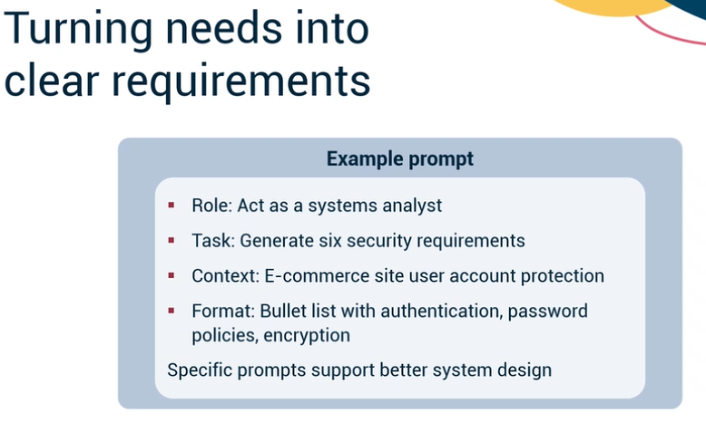

Reading: Generating AI-Driven Templates and Artifacts
Estimated time: 7 minutes

Introduction
Generative AI is rapidly transforming traditional systems and business analysis approaches, particularly in how teams create essential project artifacts. From stakeholder interview templates to detailed requirements documents and user stories, AI can dramatically accelerate and enhance the quality of these deliverables. This reading provides hands-on guidance for leveraging generative AI to generate templates, artifacts, and tailored communications, focusing on effective prompt engineering and practical examples.

Crafting AI prompts for stakeholder interview templates
Creating effective stakeholder interview templates is a foundational step in systems analysis. With generative AI, you can streamline this process by designing prompts that instruct the AI to generate well-structured, professional templates tailored to different stakeholder groups.
Begin by identifying the type of stakeholder you wish to interview, such as end-users, managers, or technical team members. Then, construct prompts that specify the desired format, tone, and focus areas.
Let's look at this example of a prompt and the expected output:
Prompt: "Generate a stakeholder interview template for end-users of a new financial software system. Include sections for user background, current pain points, desired features, and potential adoption challenges. List 8-10 open-ended questions."
- Expected output
  - Introduction section with context for the interview
  - Carefully worded questions, such as: "Can you describe a recent challenge you faced with the current system?" and "What features would most improve your daily workflow?"
  - Closing remarks and space for notes
You can also adjust the template for technical teams and managers.
Prompt for technical teams: "Create an interview template for a technical stakeholder involved in system integration. Include questions about integration requirements, data security, and technical constraints."
Prompt for managers: "Generate a stakeholder interview template for a project manager overseeing implementation. Include questions about project objectives, success metrics, and resource constraints."
This approach ensures the generated template is relevant and comprehensive for each audience. For example, a manager's template might include, "What are your key success metrics for this project?" and "What resource limitations should we be aware of during implementation?"
Next, let's look at generating requirements documentation templates using AI.

Prompt techniques for requirements documentation templates
Documentation regarding requirements is vital for project alignment and successful delivery. Generative AI can help you quickly produce documentation templates covering all necessary sections, such as functional requirements, non-functional requirements, assumptions, and constraints.
When crafting your AI prompt, specify the business context and the structural components you need. For example, you might create the following prompt:
Prompt: "Generate a requirements document template for a retail e-commerce system. The template should include sections for functional requirements, non-functional requirements, assumptions, constraints, and a summary table."
- Expected output:
  - Section headers for each required area
  - Brief instructions under each header, such as "List all business functions the system must support" under Functional Requirements
  - A summary table template for quick reference
You should also consider specifying extra instructions for industries with strict regulatory requirements, such as healthcare.
Prompt: "Generate a requirements document template for a healthcare application. Include sections for compliance requirements (such as HIPAA), user access levels, and data retention policies."
Customizing the prompt allows you to adapt these templates for different industries or project types, ensuring consistency and completeness.
Next, let's explore transforming raw business needs into structured user stories and use cases with AI.

Transforming raw business needs into structured user stories and use cases
One of the most impactful applications of generative AI is converting unstructured stakeholder input into actionable user stories, use cases, and acceptance criteria. This transformation requires prompts that guide the AI in identifying and organizing key elements according to recognized standards.
A typical workflow involves providing the AI raw stakeholder statements and asking for user stories in a specific format.
Prompt: "Using the following stakeholder input: 'We want customers to track their orders online and receive notifications about shipping status'. Then, generate user stories with acceptance criteria formatted as: 'As a [role], I want [goal], so that [reason].' Also, list at least two acceptance criteria for each story."
- Expected output:
  - User story: "As a customer, I want to track my orders online to stay informed about my shipping status."
  - Acceptance criteria: "Order status is updated in real time" and "Customer receives an email notification when the order status changes."
To further clarify, here's an example using a different business need:
Prompt: "Given the input 'Managers need to approve timesheets submitted by their teams', generate a user story and acceptance criteria."
- Expected output:
  - User story: "As a manager, I want to approve timesheets submitted by my team so that payroll is accurate and timely."
  - Acceptance criteria: "Manager receives notification when a timesheet is submitted" and "Manager can approve or reject a timesheet with comments."
Similarly, you can request use cases.
Prompt: "Based on the same input, generate a use case with actors, preconditions, main flow, and alternate flows."
- Expected output:
  - Detailed use case with actor (Manager), precondition (Team member has submitted a timesheet), and step-by-step flows for approval and rejection scenarios.
Applying these workflows turns business needs into actionable and structured artifacts. Now, let's explore how generative AI can support stakeholder communications.

AI-driven templates for stakeholder communications
Effective communication with stakeholders is critical throughout a project's lifecycle. Generative AI can automate the creation of professional communication templates for various scenarios, such as status updates, validation requests, and project summaries.
To generate these templates, instruct the AI to tailor the message for the recipient and context. For example:
Prompt for a status update email: "Generate a status update email template for stakeholders, summarizing project progress, key milestones achieved, and next steps. Use a professional but approachable tone."
- Expected output:
  - Subject line, such as "Project Update: Q2 Milestones Achieved"
  - Sections for progress summary, upcoming activities, and contact information
And for requirement validation requests, you can use the following prompt:
Prompt: "Create an email template requesting validation of attached requirements documents, including instructions for feedback and a deadline for response."
Sample output:
- Clear subject line, such as "Action Required: Review and Validate Requirements Document"
- Message body with purpose, instructions for review, deadline for response, and a contact for questions
You can also create a prompt for a project alignment summary.
Prompt: "Generate a project alignment summary template for communicating revised project goals to internal and external stakeholders."
- Expected output:
  - Executive summary section
  - Bullet points outlining revised goals
  - Call-to-action for stakeholder feedback
You can quickly generate communication templates for any stakeholder scenario by varying the prompt.

Conclusion
Generative AI is reshaping analysis work by accelerating the creation of templates, artifacts, and communications. Its real strength lies in extending the analyst's capabilities, allowing deeper insight and collaboration. Rather than replacing expertise, AI enhances it, offering a more efficient and adaptable approach to producing essential templates, artifacts, and project deliverables.

Summary
In this reading, you learned that:
- Generative AI enables rapid and consistent creation of essential business analysis artifacts, from stakeholder interview templates to requirements documents and user stories.
- Professionals can efficiently produce tailored, high-quality templates and communications for diverse stakeholder groups by mastering prompt engineering.
- Applying AI-driven techniques ensures that project documentation is comprehensive, structured, and aligned with stakeholder needs, supporting successful project outcomes.

Designing Smart Stakeholder Interviews Feb 25, 2026
This content focuses on designing effective stakeholder interviews and utilizing generative AI to convert input into structured requirements.
Understanding Stakeholders
- Identify stakeholders and their roles to tailor interview questions effectively.
- Recognize differing priorities, such as project managers focusing on timelines and users on usability.
Prompt Engineering for Interviews
- Design questions that provide context for AI tools to generate clear answers.
- Structure questions to guide stakeholders from broad goals to specific features.
Utilizing AI for Requirement Structuring
- Use generative AI to create interview flows that enhance information gathering.
- Transform raw stakeholder input into organized requirements, such as user stories and acceptance criteria, while identifying gaps in information.
These techniques improve the quality of analysis and project outcomes by aligning closely with stakeholder needs.
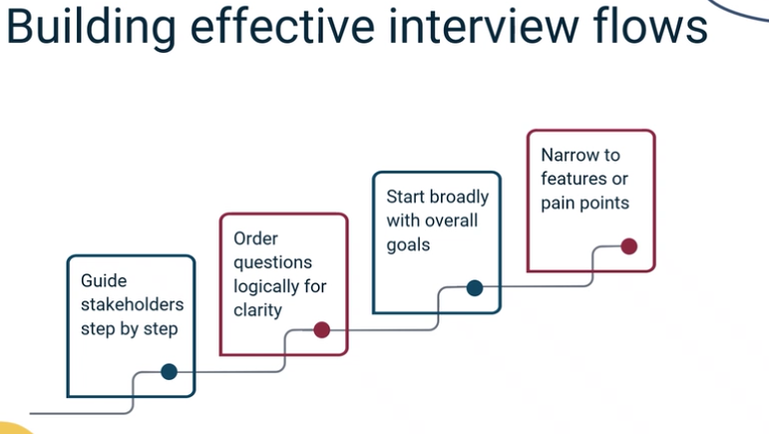

Lab: Prompt Engineering, Stakeholder Interviews, and Simulation
Estimated time: 30 minutes

Learning objectives
After completing this lab, you will be able to:
- Create effective persona-driven prompts to simulate stakeholder conversations
- Conduct structured interviews using AI tools to gather business requirements
- Transform interview insights into organized, actionable requirements

Introduction
This lab focuses on using persona-driven prompts to simulate stakeholder interviews and capture business requirements. You will work with an AI tool like ChatGPT or Claude to practice asking questions, gathering information, and organizing your findings. This skill helps you prepare for real conversations with stakeholders by letting you test and refine your approach in a safe, repeatable way.
You will create interview prompts, simulate a conversation with a stakeholder persona, and turn the results into structured requirements. By the end, you will have a clear process for moving from raw interview data to organized, usable requirements.

Required tools
- Web AI tool (ChatGPT or Claude)

Exercise 1: Build and run your stakeholder interview
In this exercise, you will design an interview prompt, create a stakeholder persona, and conduct a simulated interview. You will practice asking targeted questions and gathering detailed information about a project scenario.

Step 1: Define your project scenario and stakeholder persona
- Choose a project or business scenario you want to explore (for example: a mobile banking app, a customer service platform, or an e-commerce website).
- Create a detailed stakeholder persona by identifying:
  - Their role (e.g., Product Manager or Marketing Director)
  - Their responsibilities
  - Their goals for the project
  - Their concerns or constraints

Step 2: Write and test your interview prompt
- Write a prompt that instructs the AI to act as your chosen stakeholder. Include the persona details in your prompt.
Example:
You are Alex, a Product Manager for a mobile banking app. You care about security and user experience. Please answer my questions about the app's needs and priorities as if you are Alex.

- Open your web AI tool and paste your prompt to begin the interview.

Step 3: Conduct the interview
- Ask 3–5 interview questions focusing on:
  - The stakeholder's main goals
  - Key challenges they face
  - Desired outcomes for the project
- As the AI responds, ask 2–3 follow-up questions to dig deeper into important details or clarify anything unclear.
Hint:
Effective follow-up questions include:
- "Can you tell me more about…?"
- "What would success look like for this feature?"
- "What concerns do you have about…?"
- "How do you prioritize between [X] and [Y]?"

Exercise 2: Transform interview insights into structured requirements
In this exercise, you will use AI to help organize your interview findings into clear, structured requirements. You will learn to identify key needs and present them in a professional format.

Step 1: Review your interview and identify key themes
- Read through your interview conversation and identify the most important information, including:
  - Business goals mentioned by the stakeholder
  - Specific needs or requirements
  - Constraints or limitations
  - Success criteria

Step 2: Use AI to generate structured requirements
- Prompt the AI to organize your interview into a clear requirements format.
Example prompt:
Using this interview transcript, create a structured requirements summary with clear sections for business goals, user needs, functional requirements, and constraints.

- Review the AI's output and verify it captures all important details accurately.
- If anything seems unclear or missing, prompt the AI to refine or expand specific sections.
Example refinement prompt:
Expand the functional requirements section to include specific user stories or acceptance criteria.

Hint:
Sample requirements structure:
Business Goal | User Need | Functional Requirement | Constraint | Success Criteria
What stakeholder wants to achieve | Who needs this and why | Specific feature or capability | Limitation or requirement | How to measure success

Summary
In this lab, you practiced using AI-driven prompts to simulate stakeholder interviews and transform conversational insights into structured requirements. You learned how to create effective personas, ask targeted questions, and use AI tools to organize information into professional formats. These skills prepare you for real stakeholder conversations by helping you practice your interviewing approach, refine your questions, and develop structured documentation habits.
Remember that the key to successful requirements gathering is asking clear questions, listening carefully to responses, and organizing information in a way that guides project decisions. As you continue to practice these techniques, you'll become more confident in both simulated and real-world stakeholder interactions.
Using Generative AI to Simulate Stakeholder Interviews Mar 10, 2026
This video lecture focuses on using generative AI to create realistic interview simulations for practicing business analysis skills.
Understanding the Challenge of Traditional Interviews
- Traditional stakeholder interviews are challenging due to the diversity of perspectives and unpredictable responses from different stakeholders.
- Arranging practice sessions with live partners is time-consuming and may not cover all personality types.
Benefits of Generative AI in Simulations
- Generative AI allows for consistent and repeatable practice by simulating a wide range of stakeholder personas, enhancing questioning and listening skills.
- Customization of AI responses can help practice specific skills, such as active listening or managing unclear feedback.
Advanced Techniques for Effective Simulations
- Users can create challenging scenarios by prompting AI to provide ambiguous responses or introduce constraints, preparing for real-world unpredictability.
- Prompt engineering is crucial for maintaining focus and realism in practice sessions, helping to develop resilience and adaptability in interviews.
Using Generative AI to Generate Requirement Specs Mar 10, 2026
This video lecture focuses on using Generative AI to create requirement specifications for projects.
Types of Requirement Specifications
- Functional requirements detail what the system must do, such as user account creation or messaging features.
- Non-functional requirements set quality standards, like system speed and security, for example, an airline website needing to load quickly.
User Stories and Use Cases
- User stories describe features from the user's perspective, explaining why a feature is desired, such as tracking an order in a food delivery app.
- Use cases outline the steps a user takes to achieve a specific goal, like updating patient records in a hospital system.
Transforming Feedback with AI
- The process starts with collecting unstructured stakeholder input, which can be organized by AI into clear requirements.
- Iterative prompting allows for refining AI-generated documents to ensure accuracy and completeness, addressing any missing or vague requirements.
Overall, the lecture emphasizes how Generative AI can streamline the requirements analysis process, turning scattered feedback into structured documentation.
Generating BPMN Diagrams from Text Prompts Using Generative AI Mar 10, 2026
This video lecture focuses on generating BPMN diagrams from text prompts using Generative AI.
Understanding BPMN
- BPMN stands for Business Process Model and Notation, a method for mapping organizational processes.
- Key elements include tasks (actions), events (occurrences), gateways (decisions), and flows (connections).
Creating BPMN Diagrams with AI
- Use prompt engineering to convert plain text descriptions into BPMN diagrams.
- Break down processes into clear steps, roles, and decisions for effective AI prompting.
Benefits of Generative AI
- AI can produce BPMN diagrams in various formats, such as BPMN XML or structured outlines.
- It helps structure unorganized content and can suggest process optimizations, enhancing workflow efficiency.
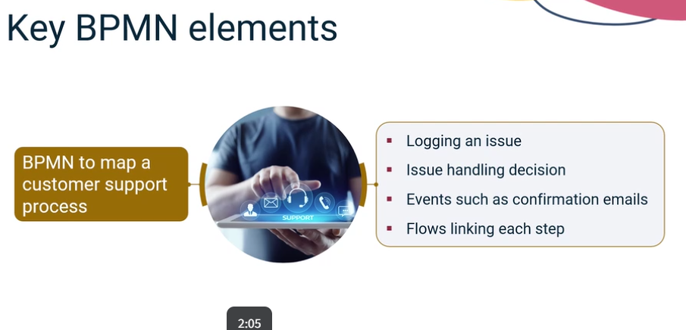
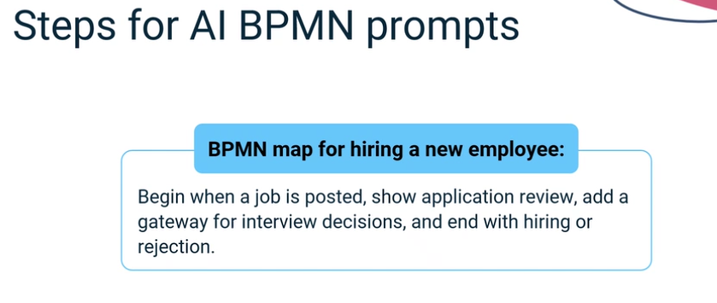
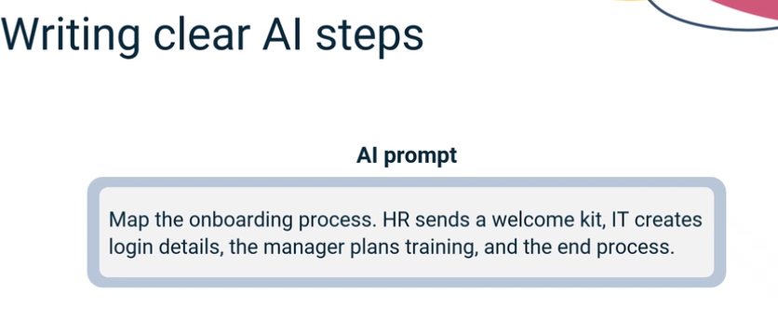

Auto-Creating Process Flowcharts and Customer Journey Maps Using Generative AI Mar 10, 2026
This content focuses on using generative AI to create process flowcharts and customer journey maps, highlighting the efficiency and clarity these tools can bring to business processes.
Process Flowcharts
- Generative AI can transform plain language inputs, like meeting summaries, into visual flowcharts, saving time and effort.
- For example, a simple decision-making prompt can be converted into a clear diagram with decision points and branches.
Customer Journey Mapping
- AI tools can create customer journey maps that illustrate the stages customers go through, including their feelings and actions.
- This helps teams in user experience and service design to visualize the customer experience comprehensively.
Updating and Improving Diagrams
- AI simplifies the process of updating diagrams; a single change in the description can instantly refresh the flowchart.
- This ensures that documentation remains accurate and reduces the risk of errors from outdated information.
Designing System Architecture Mar 10, 2026
This video lecture focuses on designing system architecture using generative AI to create effective architecture diagrams from high-level requirements.
Key Components of System Architecture Diagrams
- System architecture diagrams outline the important connections and components of a project, such as user interfaces, databases, and email services.
- Key parts include front-end services (user interaction) and back-end services (processing tasks), along with interfaces that connect different services.
Using Generative AI for Diagram Creation
- Generative AI can quickly generate architecture diagrams by using clear prompts that describe the system's purpose and features.
- Data flow diagrams illustrate how data moves through the system, helping stakeholders understand the process and guiding developers in their work.
Benefits of Generative AI in System Design
- AI tools streamline the creation of both component and data flow diagrams, making it easier to visualize complex systems.
- This approach enhances communication among teams, speeds up the development process, and allows for quick adjustments as project needs evolve.
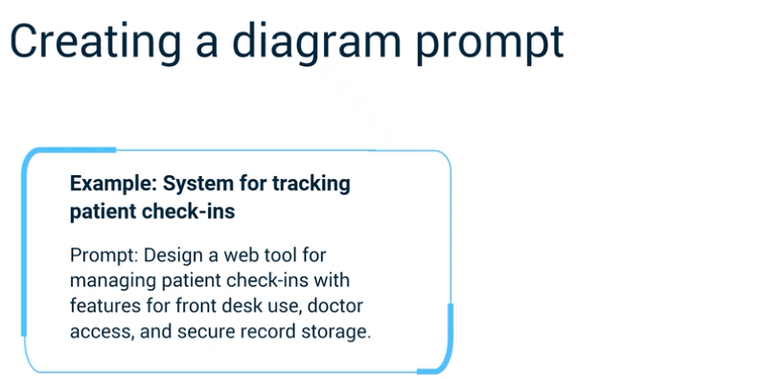

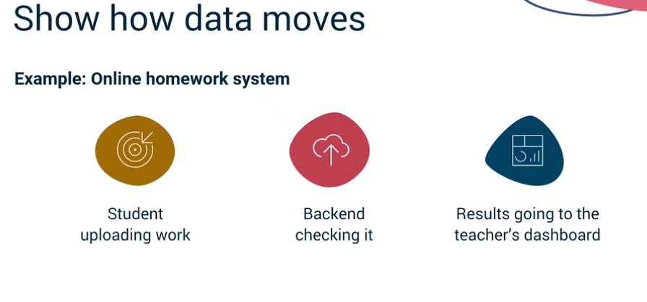
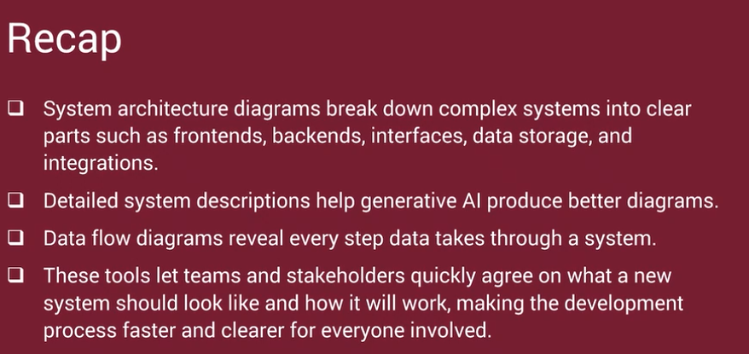

Converting Process Notes into Structured Diagrams Using Generative AI Mar 10, 2026
This video lecture focuses on how generative AI can transform unstructured process notes into structured visual diagrams.
Using Generative AI for Diagram Creation
- Generative AI can convert text-heavy notes from meetings or emails into organized visual diagrams, such as flowcharts and BPMN diagrams.
- By providing a text prompt summarizing key ideas, the AI can quickly structure the information into a logical format, saving time and reducing errors.
Types of Diagrams Generated
- Flowcharts outline the flow of tasks or decisions, while BPMN diagrams provide detailed business process modeling.
- Other diagrams include data flow diagrams and customer journey maps, which help visualize user experiences and identify areas for improvement.
Effective Prompt Design
- The success of the generated diagrams relies on how well the user designs the prompts, including all key steps and decisions.
- Providing examples in prompts can enhance the accuracy of the AI's output, making it easier to create polished diagrams.
Applications in Various Roles
- Business analysts, UX designers, and process engineers can leverage these techniques to improve communication and streamline processes.
- By using generative AI, teams can turn messy notes into clear diagrams, facilitating better collaboration and efficiency.

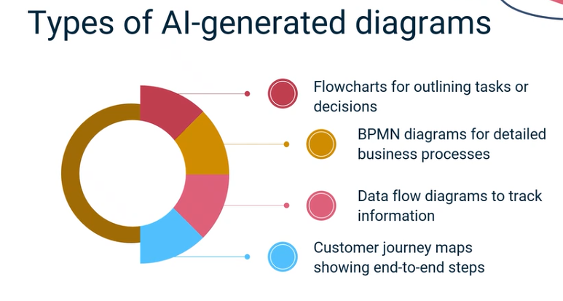
Using Generative AI to Critique Existing Workflows Mar 11, 2026
This video discusses how generative AI can analyze workflows to identify inefficiencies and suggest improvements.
Workflow Critique
- Generative AI examines workflows to find bottlenecks and areas where processes slow down.
- It highlights the importance of workflow critique in organizations with complex processes and changing needs.
Improving Workflow Efficiency
- Effective workflows have clear ownership, logical order, and minimal handoffs to reduce delays.
- Generative AI can review workflows and compare them against best practices to identify unnecessary steps.
Recommendations for Optimization
- After analyzing workflows, AI provides suggestions to remove redundant steps and clarify responsibilities.
- Real-world examples, such as in software development, illustrate how AI can streamline processes and enhance efficiency.
Venkatesh, this section is a perfect overlap with your professional background as a Solutions Architect and Technical Lead. It moves beyond just creating diagrams and starts focusing on critiquing and optimizing the logic behind those processes—something you likely do daily in your project management and AI agentic work.
Here are the correct answers for the Practice Quiz: Workflow Review and Business Rules Documentation:

1. Turning Unstructured Notes into Structured Diagrams
- Answer: It reads through text-based notes, identifies key steps and decisions, and organizes them.
- Why: AI acts as a semantic parser. It can take a messy meeting transcript or a collection of Slack messages and identify "Wait" states, "Action" items, and "Decision" diamonds to generate the logic for a BPMN or flowchart.

2. Designing Dashboards and Visualizing Data
- Answer: It interprets plain-language prompts, identifies key metrics, and generates dashboards with charts and visuals.
- Why: Modern AI tools (like the ones we used in the Power BI/Tableau lab) allow you to ask, "Show me a bar chart of patient no-shows by clinic location over the last 6 months," and automatically generate the DAX or SQL code needed to render that visual.

3. Improving Workflow Analysis
- Answer: It reviews process descriptions to identify redundant steps, unclear responsibilities, and unnecessary handoffs.
- Why: This is "Workflow Critique." By feeding a process into an AI, you can ask it to perform a bottleneck analysis. For your NexaCare project, an AI might point out that waiting for a manual confirmation call after an automated SMS is sent is a redundant step that could be removed.

Architect's Strategy Tip:
In your Zenith Finance Tracker project, you can use these exact principles. You can feed your current data-flow logic into an AI and ask: "Identify potential points of failure or data latency in this Google Sheets integration." It’s like having a peer reviewer available 24/7.
You're making great time! Would you like to dive into the "Visual Reporting" lab next, or shall we go straight to the Graded Quiz for this module?

Generating Summaries, Dashboards, and Visual Insights Using Generative AI Mar 11, 2026
This video lecture focuses on how Generative AI can effectively transform raw data and documents into actionable insights, summaries, and dashboards.
Understanding Data Overload
- Many organizations struggle with unstructured data, such as lengthy emails and reports, which can hinder timely decision-making.
- Generative AI addresses this challenge by quickly analyzing and summarizing complex information, ensuring critical insights are easily accessible.
AI-Powered Summarization Techniques
- Generative AI can create concise executive summaries from extensive documents, highlighting key points and action items.
- This technology allows teams to stay aligned and informed without the need for manual review of large volumes of text.
Creating Visual Dashboards and Narratives
- AI streamlines the creation of dashboards by generating specifications from plain language prompts, making performance metrics easily visualized.
- Additionally, it can transform summarized data into compelling narratives that provide context and meaning, helping leaders make informed decisions.
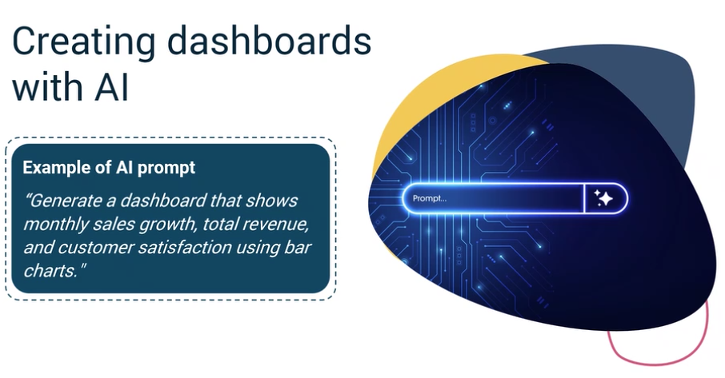
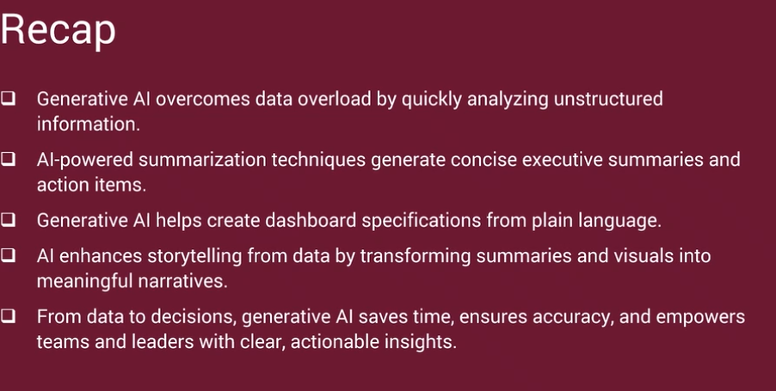

Using Generative AI for Document Review and Communication Templates Mar 11, 2026
This video discusses how generative AI can enhance document review and the creation of communication templates.
Document Review with Generative AI
- Generative AI can quickly scan long requirement documents, highlighting important information and identifying gaps or contradictions.
- It helps teams resolve issues by analyzing documents for inconsistencies, such as conflicting statements about project features.
Creating Executive Summaries and Templates
- AI can generate tailored executive summaries and communication templates based on user prompts, adjusting the language and detail for different audiences.
- It streamlines routine communications by creating standardized templates for meeting minutes, project updates, and stakeholder communications, ensuring clarity and consistency.
Overall, generative AI significantly reduces the time spent on document review and communication tasks, making processes more efficient.
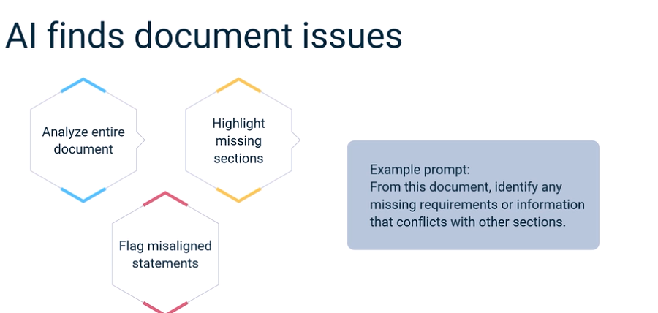
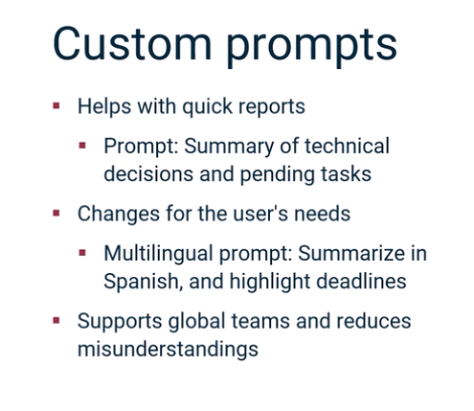
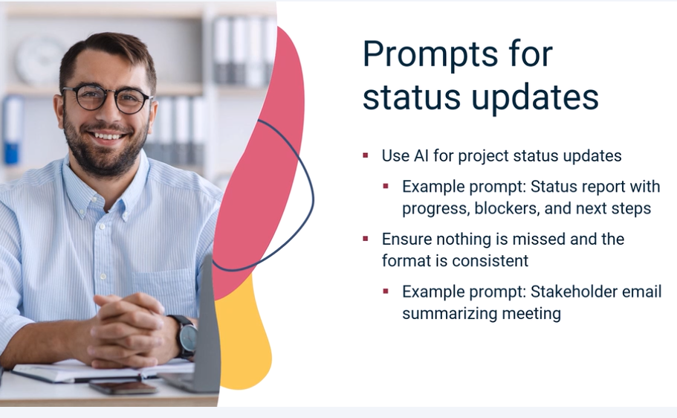
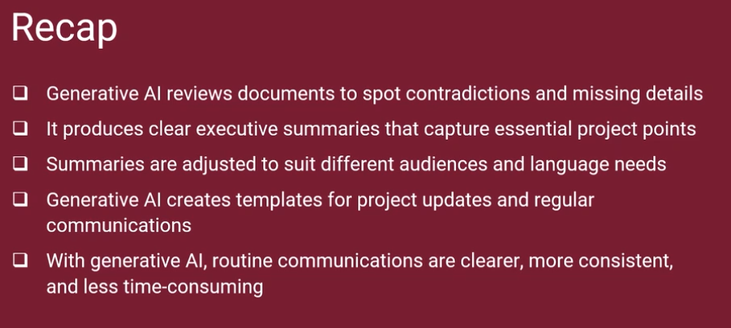

Auto-Translating Documents and Stakeholder Mapping with Generative AI Mar 11, 2026
This course content focuses on how generative AI can enhance document translation and stakeholder mapping.
Document Translation and Simplification
- Generative AI simplifies complex technical reports into plain language summaries, making them accessible for non-technical teams.
- It can translate documents into various languages while adapting tone and context to fit cultural norms, facilitating smoother communication across global teams.
Stakeholder Mapping
- Stakeholder mapping identifies project participants, their interests, and influence levels, which generative AI can automate by analyzing project briefs.
- AI organizes stakeholder information into structured maps or tables, highlighting roles and influence, and suggests tailored communication strategies for different stakeholder groups.
Strategic Engagement and Collaboration
- Generative AI helps teams engage effectively by providing insights into communication strategies based on stakeholder analysis.
- It encourages strategic thinking by identifying patterns and suggesting adjustments to communication methods, ensuring all groups remain informed and engaged.
Generating Test Cases and Scenarios Using Generative AI Mar 24, 2026
This video focuses on using Generative AI to create test cases and scenarios from requirement documents efficiently.
Understanding Generative AI in Testing
- Generative AI analyzes detailed requirement documents to identify key system behaviors, valid and invalid inputs, expected outcomes, and potential error conditions.
- It transforms these requirements into structured test cases using formats like Given/When/Then, making them easy to follow.
Benefits of Using Generative AI
- The AI can detect edge cases and unusual inputs that humans might overlook, ensuring comprehensive test coverage.
- It can generate performance and stress test scenarios, helping teams prepare for high-load situations and identify risks before testing begins.
Real-World Application
- In practical scenarios, analysts can feed requirements from applications (e.g., banking apps) to the AI, which then produces a robust set of test cases tailored to different user roles and conditions.
- This approach reduces manual effort, speeds up the testing process, and enhances the quality and completeness of tests across various system functions.
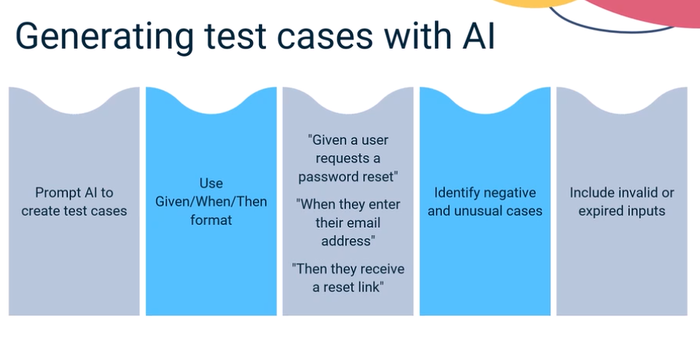

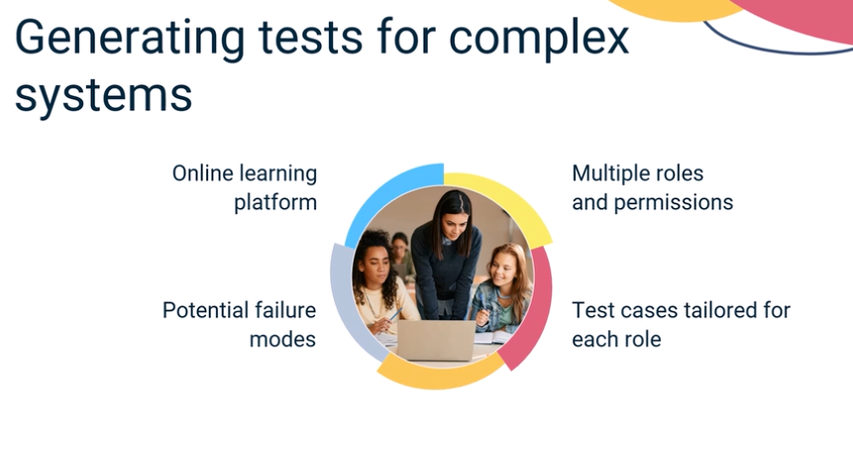
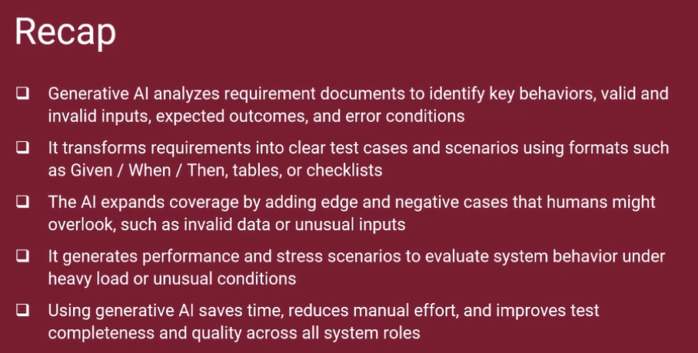

Simulating System Deployment and Validation with Generative AI Mar 24, 2026
This video lecture focuses on how generative AI can enhance the simulation and planning of system deployments across various environments.
Simulation of Deployment Environments
- Generative AI creates virtual models of cloud, on-premises, and hybrid systems to predict performance under real-world conditions.
- It identifies potential risks, such as integration failures and network issues, before actual deployment.
Deployment Checklists Generation
- AI generates tailored step-by-step checklists for different environments, ensuring that all necessary checks are performed.
- These checklists help reduce human error and improve clarity during the deployment process.
Rollback and Contingency Planning
- Generative AI assists in creating rollback plans to restore systems to their previous state in case of deployment failures.
- It outlines procedures for incident reporting and compliance, ensuring a quick and organized recovery process.
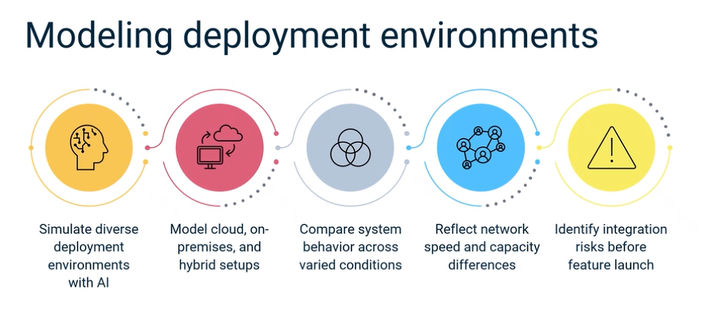
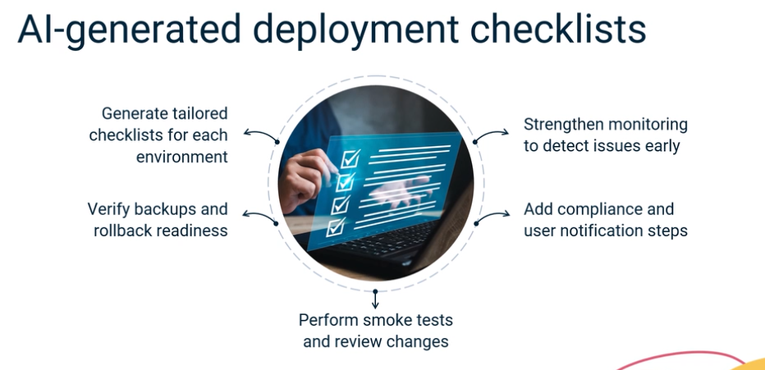
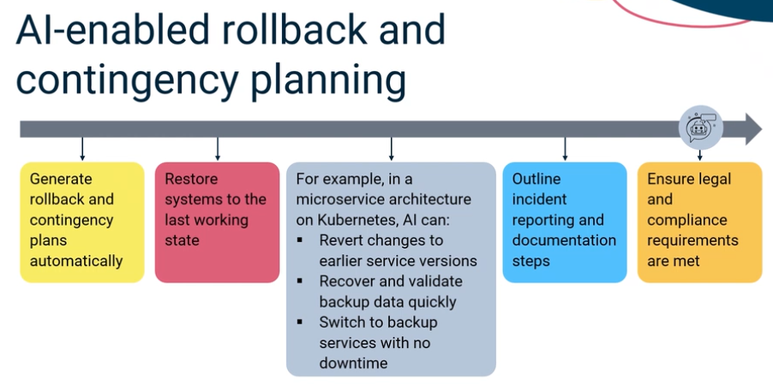
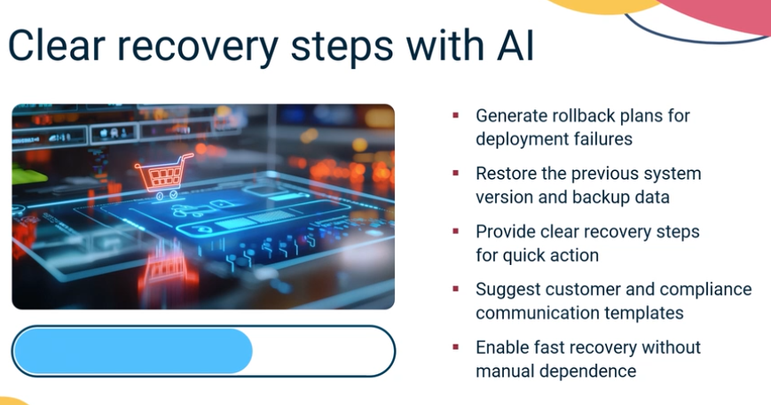

1. Simulating Deployment and Validation
- Answer: By generating synthetic data for testing system responses.
- Why: In complex environments (like your NexaCare 3.0 migration), using real patient data is a security risk. Generative AI can create "synthetic" but realistic datasets—names, medical codes, and timestamps—to see how the system handles high-volume deployment without compromising privacy.

2. Identifying Gaps or Contradictions
- Answer: By using AI to analyze and compare document elements.
- Why: AI is excellent at "cross-referencing." It can look at your System Requirement Specification (SRS) and your Test Plan to ensure every requirement has a corresponding test case, flagging any "orphaned" requirements that aren't being tested.

3. Creating Effective Test Cases
- Answer: By analyzing user requirements and generating scenarios based on patterns.
- Why: Instead of writing one test case at a time, you feed the AI your user stories. It identifies patterns and automatically generates "Happy Path," "Edge Case," and "Negative" scenarios (e.g., what happens if a user enters a Telugu name into an English-only field?).

4. Enhancing System Validation
- Answer: Generative AI generates test cases and scenarios to ensure comprehensive validation.
- Why: The "enhancement" comes from coverage. AI can think of 100 variations of a user journey in seconds, ensuring that validation is much more thorough than what a human could manually draft in the same timeframe.

5. Creating Test Scenarios
- Answer: By generating new scenarios based on patterns.
- Why: AI doesn't just copy old tests; it understands the logic of your system. If it sees a pattern in how your "Zenith Finance Tracker" handles CSV uploads, it can generate new scenarios for different file encodings or corrupted headers.

Technical Lead's Insight:
For your automated AI testing project, remember that AI's biggest strength here is Edge Case Discovery. While we humans tend to test for how things should work, AI is great at imagining how things might break.
You're almost at the finish line for this module! Would you like to tackle the "Security Compliance and Scalability" quiz next, or shall we look at the final Graded Quiz?
Ensuring Security Compliance with Generative AI Mar 24, 2026
This video lecture focuses on the role of Generative AI in ensuring security compliance within organizations.
Understanding Security Compliance
- Security compliance involves adhering to regulations that govern the management, storage, and sharing of information, such as GDPR, HIPAA, and ISO 27001.
- Organizations must meet these standards to protect sensitive data, build trust, and avoid legal issues.
Using Generative AI for Risk Analysis
- Generative AI analyzes business processes and system architectures to identify potential security risks and weaknesses.
- It provides proactive feedback by reviewing documentation and design plans, helping teams address vulnerabilities early.
Generating Compliance Documentation
- AI can create customized compliance reports and checklists, streamlining the documentation process for audits and regulatory reviews.
- It also assists in translating documents into multiple languages, ensuring consistent compliance across global operations.
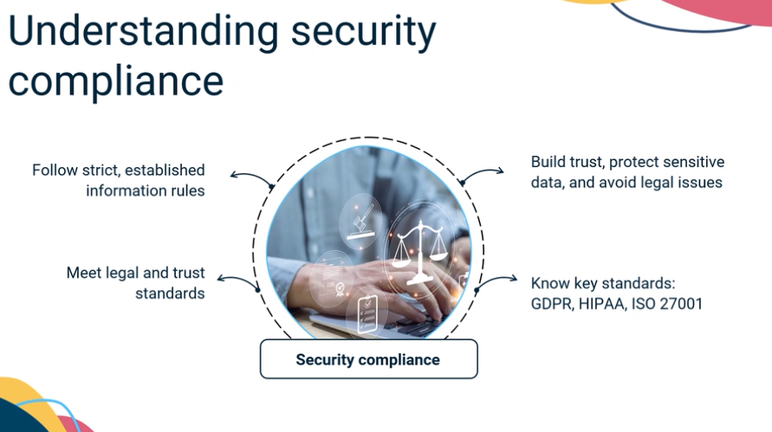
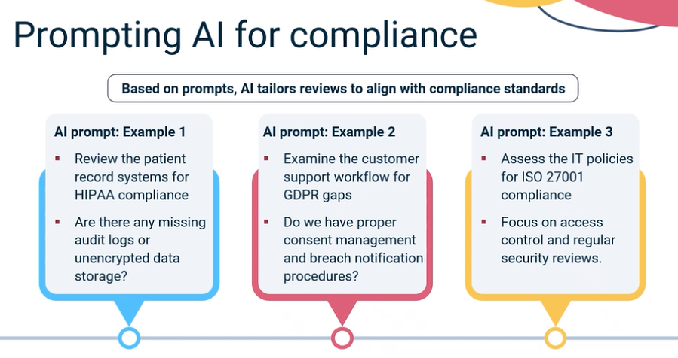
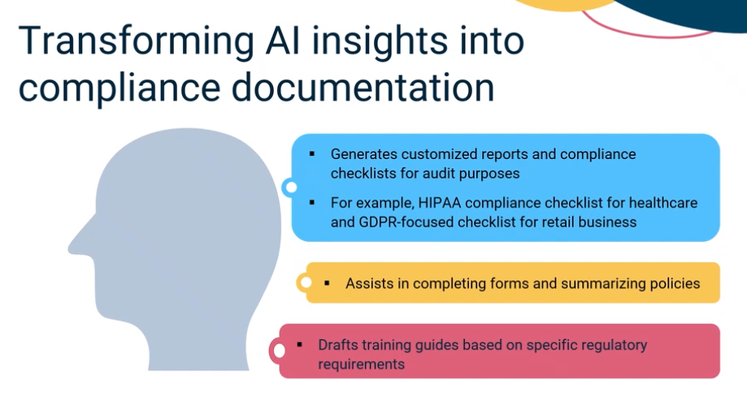
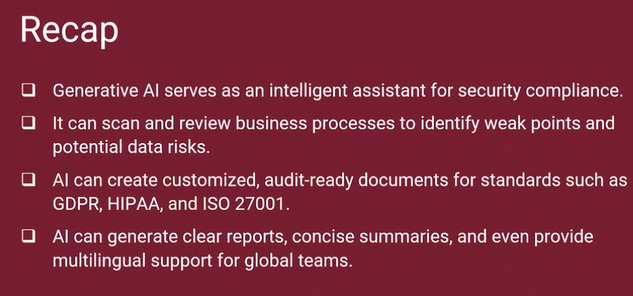

Optimizing Performance and Scalability Using Generative AI Mar 24, 2026
This video focuses on how AI can enhance system performance and scalability.
Understanding AI's Role
- AI analyzes large amounts of system data quickly, identifying performance issues and bottlenecks that manual reviews might miss.
- It can highlight specific components causing delays, such as slow payment gateways during high traffic.
Optimizing System Design
- AI suggests scalable design patterns like microservices and caching layers to improve system efficiency.
- It can predict traffic surges and automatically adjust resources, ensuring smooth operation during peak times.
Enhancing User Experience
- AI helps streamline data flow and optimize user traffic management, maintaining a positive customer experience even under heavy load.
- Insights from AI can inform business strategies, allowing teams to prepare for high demand proactively.
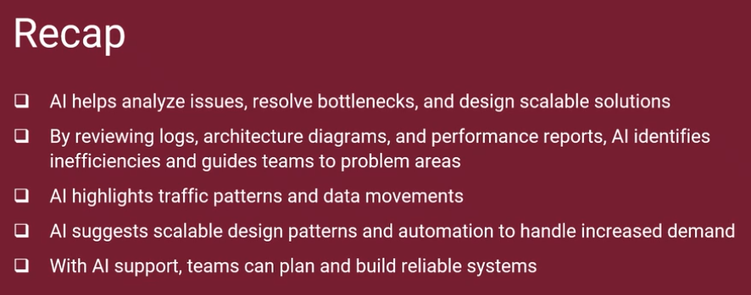

1. Handling Sensitive Information
- Answer: Encrypt and limit access
- Why: This follows the principle of Least Privilege. Especially in healthcare, patient data (PII) must be encrypted both at rest and in transit. Access should only be granted to the specific users or service accounts that absolutely require it for a task.

2. Analyzing System Performance
- Answer: Latency measurement
- Why: In real-time systems (like your AI agents or an Azure-hosted app), latency is the king of metrics. It measures the delay between a user's request and the system's response. High latency leads to a poor user experience and can indicate underlying infrastructure bottlenecks.

3. Ensuring Security Compliance
- Answer: By following regulatory guidelines
- Why: Compliance is about adhering to established laws and standards like HIPAA (for your healthcare projects), GDPR, or SOC2. Generative AI can help by scanning your architecture and documentation to ensure you aren't violating these specific regulatory rules.

4. Optimizing System Scalability
- Answer: By automating resource allocation
- Why: This is the core of "Elasticity." Instead of having a human manually add servers, generative AI can help design or trigger Auto-Scaling rules that automatically add or remove resources based on real-time demand.

5. Implementing AI Security
- Answer: Conducting regular audits
- Why: Security isn't a one-time setup; it’s a cycle. Regular audits (which AI can help automate) check for new vulnerabilities, outdated configurations, and unauthorized access attempts to ensure the system stays hardened against threats.

Venkatesh's Architect Insight:
For your Multi-Agent AI project, these factors are vital. If your "Supervisor Agent" has high latency (Question 2), it will slow down the entire chain. Likewise, if you don't encrypt and limit access (Question 1) to the API keys your agents use, your entire infrastructure could be at risk.

Document Analysis & Inconsistency
1. Identifying Gaps or Contradictions (Amira)
- Answer: By generating a summary and comparing it with the original document for inconsistencies
- Why: This "Mirroring" technique helps an analyst spot what is missing. If the AI summary highlights 5 core requirements but the original document had 6, or if the summary reveals a logic conflict, the analyst can quickly target the error.
4. Improving Project Alignment (John)
- Answer: Use generative AI to analyze and compare document versions
- Why: This is a classic "Diff" analysis but at a semantic level. AI can look at the Business Requirements Document (BRD) from last month and the System Design Document (SDD) from this month to ensure the technical architecture still aligns with the original business goals.
5. Identifying Gaps in a Project Document (Alex)
- Answer: Use AI to highlight inconsistencies
- Why: AI is programmed to find logical "breaks." For your NexaCare migration, it could flag if a data field is marked as "Mandatory" in the UI section but "Optional" in the Database schema section.

Stakeholder Strategy & Communications
2. Benefit of Stakeholder Personas (Noah)
- Answer: It allows for rapid generation and iteration of personas based on data analysis
- Why: Personas help you tailor your communication. AI can quickly generate profiles (e.g., "The Skeptical Executive" or "The Overworked Clinician") based on project data, allowing you to test how each might react to your system changes.
3. Creating a Communication Plan (Chloe)
- Answer: Identify key stakeholders
- Why: You cannot build a plan without knowing who you are talking to. Identification is always the first step in the stakeholder management lifecycle.
6. Generating an Executive Brief (Leah)
- Answer: Analyze existing documents for gaps
- Why: An executive brief must be grounded in the most accurate and up-to-date information. Before generating the final summary, you must ensure the source data is complete and consistent.

Tool Integration
7. Integrating AI into Jira (Sophia)
- Answer: Use Jira's API to connect generative AI
- Why: For a Systems Architect, using the API (Application Programming Interface) is the standard, secure way to allow two different software systems (Jira and an AI model like Gemini) to talk to each other and exchange data automatically.

Section 1: Requirements & Unstructured Data
1. Converting notes to BPMN (Emma)
- Answer: Identify key processes and entities in the notes
- Why: AI works best when you give it the "Lego bricks" first. You must define the Start, End, and Key Actors before the AI can draw the connections.
3. Documenting User Stories (David)
- Answer: Use AI to automate the conversion of inputs into structured formats
- Why: AI’s superpower here is formatting. It takes a messy paragraph and turns it into the "As a [User], I want [Feature]" structure instantly.
6. Gathering Requirements (Liam)
- Answer: Use prompt engineering to extract key information
7. Efficient Conversion (Leah)
- Answer: Use generative AI tools to automatically generate user stories and acceptance criteria from raw meeting notes.
9. Ensuring Accuracy (Ethan)
- Answer: Manually review the notes and then use generative AI to generate documentation based on identified key points
- Why: This is the "Gold Standard" workflow. Human identifies the truth -> AI structures the truth.

Section 2: Process Modeling & Workflow
8. Improving Efficiency (Ravi)
- Answer: Use generative AI to create a BPMN diagram that highlights inefficiencies and suggests improvements.
10. Generating BPMN from Inputs (Ava)
- Answer: Use prompt engineering to convert text inputs into structured BPMN diagrams.
11. Preparing notes for BPMN (Jamie)
- Answer: Identify key activities, stakeholders, and decision points before prompting AI to generate the diagram.
12. Identifying Bottlenecks (Amir)
- Answer: Provide the workflow description and ask AI to analyze inefficiencies and suggest improvements.

Section 3: Integration & Platforms
2. Integrating with Jira/Power BI (Alex)
- Answer: Utilize APIs provided by the platforms to connect and automate data flow
- Why: APIs are the professional way to ensure data integrity and security between your AI and your enterprise tools.
4. Successful Jira Integration (Nina)
- Answer: Configure the AI to automatically generate reports based on Jira data
5. Applying Prompt Engineering (Olivia)
- Answer: Use AI to generate user stories from unstructured data

Section 4: Communication & Quality
13. Refining User Stories (Rosa)
- Answer: Review the AI-generated stories and refine them with AI assistance while validating context and accuracy.
- Why: Never trust the first draft. Validation is the most important step for an Architect.
14. Tailoring Communication (Tariq)
- Answer: Ask AI to generate separate summaries tailored to each audience’s level of technical expertise and information needs.
- Why: Executives want the "ROI" and "Timeline"; Engineers want the "API specs" and "Edge cases."
15. Test Case Development (Lena)
- Answer: Use AI to generate test cases from the requirements, then review and refine them to ensure completeness and accuracy.
- Why: This directly mirrors your work with Selenium—AI can write the script logic, but you must ensure it hits the right elements on the page.

Venkatesh's Final Step:
You have 45 minutes and 2 attempts left. Once you submit this and pass, you will have officially mastered the art of AI-Enhanced Systems Analysis!
After you submit the exam, would you like to celebrate by starting your Final Project documentation, or shall we look at your next certification path?

